Nursery  N1 age 2  N2 age 3-4 | Autumn 1 | Autumn 2 | Autumn 3 | Spring 1 | Spring 2 | Summer 1 | Summer 2
Focus | 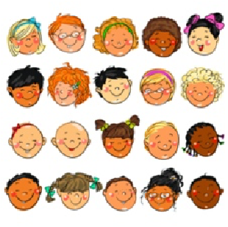  Look at me!  Do you know how special you are? Do you know some of  the amazing things our body can do?  Do you know what we use to  see/smell/hear/  taste/touch? What are your favourite things to do using  your sense? Who is in your family? | 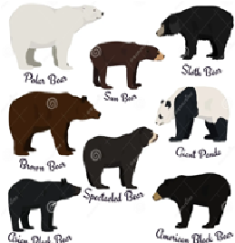  Bears  Why are bears different colours?  Why do they live in different  places? How do bees make  honey?  Is it right to steal someone's food and go into a  house uninvited? |   Special Days  What days are special to you?  When is your birthday? How old  will you be? Do you enjoy celebrating  other special days with your family?  Christmas? Diwali?  Easter? | 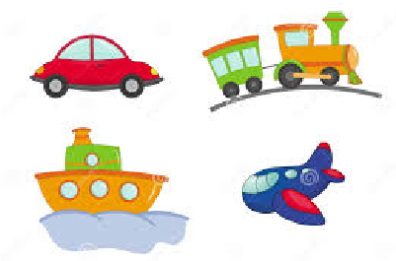  On the move  Do you enjoy going on a journey? Have you ever travelled on a train? A bus? A plane? Do you  have a trike? I wonder  how many ways you have travelled around? How  could we travel across the  sea? In the sky? Along the road? How do we stay  safe when crossing the road? | 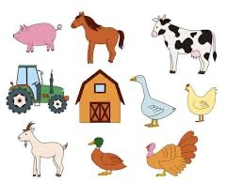  On the farm  Who lives on the farm? I wonder what noises the  different animals make? Where does milk come from? What  about our food? Would you like to grown your own beanstalk? What other vegetable plants could be grown from a seed?  I wonder which insects like to eat the leaves on our plants?  Have you ever seen a real caterpillar? I wonder what it will change into? | 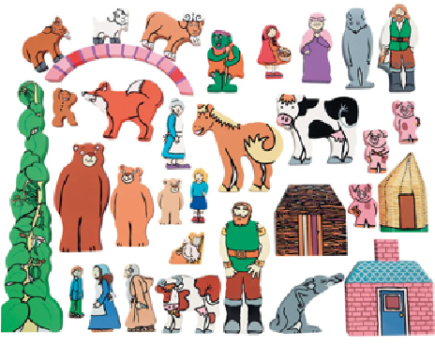Once Upon a time  Can you talk about the books that you have read? Do you have a favourite and why?  Can dress up and show us the story or use puppets to retell it? |   All Creatures Great and Small  Are all animals the same? Do you know where different  animals live? I wonder what it is like in different places round the world? What  animal do you think would make a good pet? Do you have any pets at home?
Key  Vocabulary | See, sight eyes  Smell, nose  Taste, tongue  Hear, hearing, ears, listen, touch, skin, family, love | Bear, cub, fur, camouflage look, right, wrong, mix | Celebrate, special, festival, religion, party, family, decorations, cake | Travel, journey, transport, safety, road,  walk, ride, vehicle, fast,  slow | Grow, change, life cycle, animals, plants, food, water,  care, fur, feathers, legs, horns, hooves, beak, wings, tail,  udder, | Story, adventure, character, tale, magical, once upon a  time, the end, scary, exciting, funny | wild animals, hot, cold, land,  sea, sky, pets, vet, ocean,
Key texts ‘Super 6’ | Goldilocks & the 3 bears.  5 minutes peace.  Titch.  Anna Hibiscus. Love makes a family. | Goldilocks & the 3 bears.  The everywhere bear.  We’re going on a bear hunt. Where do you live? | The first Christmas.  Santa Post.  Dear Santa.  Diwalli.  Kipper’s Birthday.  King Charles. | The 3 little pigs.  The train ride.  Duck in the truck.  Journeys and migrations.  Mr Gumpy’s motor car.  Amazing machines. | Jack and the beanstalk.  Rosie’s walk.  Farmyard, hullaballoo.  The little red hen.  A squash and a squeeze.  Life cycle of a chick. | Little Red Riding Hood The 3 little pigs.  Each peach pear plum.  Little red.  The ugly duckling.  From piglet to pig. | The gingerbread man.  The fish who could wish.  Hooray for fish.  The water princess.  Sharing a shell.  Surprising sharks.

 | Me and my amazing body. | Where’s my teddy.  Bears.
Songs, rhymes and poetry | If you’re happy any you know it.  Heads, shoulders.  Miss Polly.  Tommy thumb.  1 finger, 1 thumb. | If you go into the woods today. Teddy Bear, Teddy Bear, 5 in a Bed.  Round and round the garden. Bananas in pyjamas. Goldilocks went to the house of the bears. | Nativity Songs. The Rama and Sita song.  Mother Mary, where are you?  I sent a letter. | Train is a-coming.  Down at the station.  Row your boat.  Wheels on the bus. | Old MacDonald Had a Farm.  The Farmer’s in his Den.  Baa, Baa Black Sheep.  Higgety Pickety my red hen.  5 little ducks.  5 little peas. | This Little Pig Went to Market.  There Was a Princess Long Ago. | One, two, three, four, five, Once I caught a fish alive.  A Sailor Went to Sea.
Visit/ visitor | Exploring the school grounds and following maps. | Teddy bear’s picnic and shared family story time. |  | Road Safety Workshop | Virtual links with a real farm- Taste a variety of fruit and vegetables grown on farms in UK, discuss healthy eating. | Family forest school and gardening session. | Summer fun day and sports day with parents in school
Wow moment | Share family photographs and display in the home corner. | Footprints left by the 3 bears when they came into our nursery at the weekend (make porridge). |  | Tickets for a train journey (role play train). | Caterpillars delivery (life cycle of a butterfly) | Discover a basket of  ingredients left by Little Red Riding Hood asking us to make biscuits for Grandma. | Discover a new pet to care for and feed at nursery- a gold fish discovery!
Themed learning | Week 1: SelfPortraits  Week 2: Family photos and drawing pictures.  Week 3: Family photo frames.  Week 4: Body parts- songs and games. | Week 1: Bear hunt- different textures.  Week 2: Making bear caves and dens.  Week 3: Different types of bears- making masks.  Week 4: Teddy bears picnic- favourite cuddly toys. | Week 1: Home corner- birthday enhancements.  Week 2: Winter themed activities.  Week 3: Home corner- Christmas enhancements.  Week 4: Printing patterns- wrapping paper. | Week 1: Role play train- big construction play.  Week 2: Road safety activities- road signs.  Week 3: Small world wheeled toys, explore moving with ramps and guttering.  Week 4: Making up our own version of a song:  using ‘the wheels on the..  Car/train/bike' | Week 1: Farm animals and their young. Matching games.  Week 2: Listening games- guess the animal.  Week 3: Smallworld farm play.  Week 4: Collage farm animals.  Week 5: Farming/Gardening- planting seeds and taking care of them.  Week 6: Life cycle of a caterpillar- observe changes. | Week 1: The 3 little pigs- construction building homes.  Week 2: Building site role play- variety of materials.  Week 3: Role play shop.  Week 4: Make shopping lists.  Week 5: The gingerbread man- baking and decorating biscuits.  Week 6: Obstacle coursesmoving in different ways. | Week 1: Jungle animals small world play.  Week 2: Jungle music and dance.  Week 3: Jungle animal paintings and patterns.  Week 4: Class gold fish and a fish life cycle activity.  Week 5: Sports Day and obstacle courses.

 |  |  | Week 5: Make celebration cards-  birthdays/ Christmas.  Week 6: Perform Christmas songs to an audience. |  |  |  | Week 6: Sea creature drawings and paintings.
PSHE SMSC | Jigsaw – Being me in my world | Jigsaw - Celebrating differences |  | Jigsaw - Dreams and Goals | Jigsaw- Healthy Me | Jigsaw - Relationships | Jigsaw - Changing Me
CLL and  phonics | Elklan  Blank levels  Pre-phonics: Environmental sounds, instrumental sounds, body percussion, rhythm and rhyme,  alliteration, voice sounds. | Elklan  Blank levels  Pre-phonics: Speaking, Listening &  Attention  Environmental sounds, instrumental sounds, body percussion, rhythm and rhyme, alliteration, voice sounds. |  | Elklan  Blank levels  Pre-phonics: Speaking,  Listening & Attention Environmental sounds, instrumental sounds, body percussion, rhythm and rhyme, alliteration, voice sounds. | Elklan  Blank levels  Pre-phonics: Speaking,  Listening & Attention Environmental sounds, instrumental sounds, body percussion, rhythm and rhyme, alliteration, voice sounds.  RWI Fred games: Begin oral blending and segmenting games | Elklan  Blank levels  Pre-phonics: Speaking,  Listening & Attention Environmental sounds, instrumental sounds, body percussion, rhythm and rhyme, alliteration, voice sounds. (N1)  RWI Fred games: Begin oral blending and segmenting games (N1/N2)  Nursery RWI set 1 sounds  (pre-school children -N2) | Elklan  Blank levels  Pre-phonics: Speaking,  Listening & Attention Environmental sounds, instrumental sounds, body percussion, rhythm and rhyme, alliteration, voice sounds. (N1)  RWI Fred games: Begin oral blending and segmenting games (N1/N2)  Nursery RWI set 1 sounds  (pre-school children -N2)
Maths | Match and Sort: Begin to sort objects according to colour, size or shape.  Link numerals and amounts/Counting: Showing the right number of objects to match the numeral for 1 and  2. | Link numerals and amounts/ Counting:  Recite numbers to  5  Show ‘finger numbers’ up to 5 when joining number songs and rhymes Subitise small groups of objects.  Shape: | Shape:  Talk about and explore 2D shapes using informal and mathematical language: ‘sides’, ‘corners’; ‘straight’, ‘flat’, ‘round’.  Pattern:  Talk about and identifies the patterns around them. Use informal | Counting:  Say one number for each item in order Know that the last number reached when counting a small set of objects tells you how many there are in total.  Linking numerals and amounts: Showing the right number of objects to match the numeral to 4. | Sorting and Matching: Find and match objects which are the same.  Sort the same set of objects according to different criteria.  Shape:  Talk about and explore 3D shapes using informal and mathematical language: ‘sides’, ‘corners’; ‘straight’, ‘flat’, ‘round’. | Number:  Fast recognition of up to 3 objects, without having to count them.  Compare quantities using language: ‘more than’, ‘fewer than’.  Solve real world  mathematical problems with numbers up to 5.  Measure: | Measure: make comparisons between objects relating to size, length, weight and capacity.  Pattern:  Notice and correct an error in a repeating pattern. Extend and create ABAB  patterns – stick, leaf, stick, leaf.  Number:

 | Subitise small groups of objects. Recite numbers to  5.  Begin to show ‘finger numbers’ up to 5 when joining number songs and rhymes  Measure:  Make comparisons between objects relating to size and length. | Select shapes appropriately: flat surfaces for building, a triangular prism for a roof etc. Notice and talk about shapes in the environment. Positional  Language: Understand position through words alone.  Measure Make comparisons between objects relating to size. | language like ‘pointy’, ‘spotty’, ‘blobs’ etc.  Counting:  Say one number for each item in order:  1,2,3,4,5.  Recite numbers  beyond 5  Measure:  Make comparisons between objects relating to size, length, weight and capacity. | Experiment with their own symbols and marks as well as numerals.  Position and Direction:  Describe a familiar route using words like ‘in front of’ and ‘behind’.  Pattern: Extend and create ABAB patterns.  Shape: talk about and explore 3D shapes. | Link numerals and amounts/Counting:  Show ‘finger numbers’ up to 5. Say one number for each item in order.  Know that the last number reached when counting is the total.  Measure: make comparisons between objects: size, length, weight and capacity. | Make comparisons between objects relating to weight and capacity.  Position and Direction: Discuss routes and locations, using words like ‘in front of’ and ‘behind’. Understand and use positional language through words alone. | Showing the right number of objects to match the numeral up to 5  Compare quantities using language: ‘more than’, ‘fewer than’  Solve real world mathematical problems.  Experiment with their own symbols and marks as well as numerals.
Physical  Development  Hall time:  Write dance Gross motor activities such as ball skills, apparatus, scarves and ribbons. | Take part in group  activities that they make up themselves, or in teams e.g.: ‘following the leader’.  Identify different parts of the body through movement games.  Use one-handed tools and develop fine motor skills. | Create own obstacle course to reenact the story ‘We’re Going on a Bear Hunt’.  Choose the right resources to carry out their own plan. Work with others to move large items.  Continue to develop movement,  balancing, riding (scooters, trikes and bikes) and ball skills. | Be increasingly independent as they get dressed and undressed.  Talk about ways to stay warm in the winter.  Listen to ‘We are  Walking in the Air’ from The Snowman and move like a snowman or a snowflake to music. | Continue to develop their movement, balancing, riding (scooters, trikes and bikes) and ball skills.  Use one-handed tools and equipment, for example, making snips in paper with scissors.  Show a preference for a dominant hand. | Start to eat independently and learning how to use a knife and fork.  Move in different ways and develop vocabulary for movement e.g.: creep, tiptoe, leap. | Work with other children to build obstacle courses using large items and decide how to travel over/under/through. | Use a comfortable grip with good control when holding pens and pencils  Join in with sports day activities.  Explore moving in different ways to accompany story  ‘Walking Through the Jungle’.

