Reception | Autumn Term 1 | Autumn Term 2 | Autumn Term 3 | Spring Term 1 | Spring Term 2 | Summer Term 1 | Summer Term 2
Focus | Me and my world  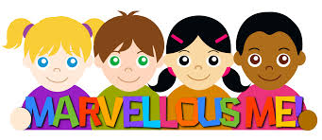  Do you know just how special you are? We can all do amazing things. We are all unique and have similarities and differences- all these things make us special.  Where do we live and what’s special about where we live.? | My Heroes  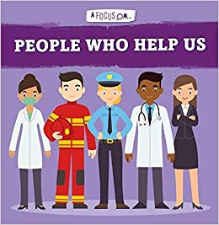  Who are your real-life heroes and heroines? What do they have in common? Who can we ask for help if we need it? Can you think of any superheroes? What special powers do they have? If you could be a superhero, what would your super power be? Get your superhero costume on and ... Let’s go! | Standing Ovation  What celebrations are important to you? How do people celebrate different festivals? What are some of the similarities and differences between some of the celebrations? | Castles, Knights and Dragons  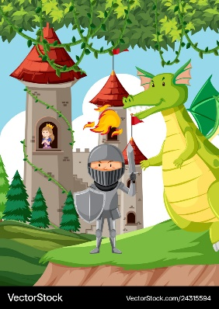  What does it mean to be brave? What do you think is inside a castle? Who may live in a castle? Can you retell a story that has a castle in it?  Lets have a tea party inside a castle and write invitations for those invited. | Spring in Our Step  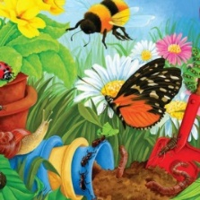  Do you know how a butterfly began its life? Have you ever wondered what plants need to grow? Do you look the same now as when you were born? How have you changed and what have you achieved? A lot of fantastic changes happen to the plants and creatures around us in this wonderful world. | Where we Live  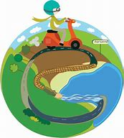  Have you ever written a letter? How do we get it to the person it is for?  What journeys have you been on before? Lets make our own journey, where shall we go? | Science Detectives  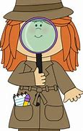What is science? Can you notice changes outside? What do these changes mean?  What do you think the moon is like? How could we get there? What do we need to take?  Our bodies are amazing things. Can you name all the parts of your body and what they do?  Do you know where different animals live? Why do some animals live under water and some in hot places?
Key  Vocabulary | Special, Unique  Similar, Different  Emotions, Happy  Sad, Fear, Scared, Anger,  Calm, Love, Sharing | Help, Nurse  Doctor, Paramedic  Firefighter, Police officer  Armed Forces, Job  Hero, Truthfulness  Imagine | Christian, Christmas  Jesus, Mary  Joseph, Hindu  Rama, Sita  Diwali, Rangoli  Diya lamp, Celebrate  Guy Fawkes, Bonfire  Fireworks, Halloween  Feelings, Emotions  Push yourself | Castle, tower, moat, turret, stone, bricks, drawbridge, knights, dragons, brave, invitation, catch, grab, hunt, kings, queens, | Life cycle, Change  Develop, Born  Cocoon/chrysalis  Seeds, Shoots  Roots, Leaves  Stem, Flower  Grow, Teamwork  Concentrate | Letters, postman, journey, map, address, landmarks, London, Plymouth, Smeaton tower, big ben. | Science, seasons, spring, autumn, winter, summer, space, forces, matter, cold, hot, warm, windy, snow, moon, rocket, helmet, boots.
Key Texts | What I like about me.  What makes me a me?  All about families.  Me and my amazing body. | People who help us series.  Supertato.  Juniper Jupiter. | Rama and Sita.  The jolly Christmas postman. | Castles.  The very last castle.  The grand old duke of York, sing a song of sixpence etc.  George and the dragon. | The extraordinary gardener.  Jack and the beanstalk.  The enormous turnip.  The very hungry caterpillar.  Life cycle of a frog.  What can you see in spring? | The jolly postman.  A walk in London.  All aboard the BoBo road. | What is science?  Tree.  Whatever next.  Funny bones.  Handa’s surprise.  Commotion in the ocean.
PSHE  SMSC | Classroom rules  Jigsaw – Being me in my world |  | Jigsaw - Celebrating differences | Jigsaw - Dreams and Goals | Jigsaw- Healthy Me | Jigsaw - Relationships | Jigsaw - Changing Me
R.E. | Plymouth agreed syllabus:  F4 Being special: where do we belong.  Harvest Festival |  | Plymouth agreed syllabus  F2: Why is Christmas special for Christians?  In addition we will explore festivals of Diwali (story of Rama and Sita) | Noah’s Ark  Chinese New Year story  Plymouth agreed syllabus:  F1: Why is the word ‘God’ so important to Christians | Plymouth agreed syllabus  F3: Why is Easter special to Christians? | Plymouth agreed syllabus  F5: Which places are special and why | Unit F6: Which stories are special and why?  Some of these stories are taught at different points in the year to fit in with our topics
Literacy | - Name writing to be taught.  - Answer what questions | - Hear initial sounds  - Identify sounds (CVC)  - Write letters | - Blend cvc  - Identify initial sound  - Retell a story  - Q: who, what, where  - Name writing | - Creating narrative  - Identify sounds in words  - Write letters  - Write simple captions and sentences | - Letter formation  - Read simple phrases  - Write simple captions and sentences | - Spell using sounds  - Write sounds with letters  - Write short sentences using letter/ sound correspondences | - Letter formation  - Reread what they’ve written to check that it makes sense  - Spell words using sound knowledge  - Write short sentences
C&L | - Engage in story time  - Learn and use new vocab  - Listening and attention  - Articulate ideas and thoughts  - Engage with non-fiction books | - Ask questions  - Listen to and talk about stories | - Vocab  - Rhyme- poem and song  - Listen and talk about the story | - Vocab: connectives  - Make predictions  - Retell story  - Listen and say rhymes and songs | - New vocab  - Use talk to solve problems and organise thinking  - Explain how things work and why they might happen  - Ask Qs to find out more and check understanding | - Listen to and talk about stories to build understanding  - Link events in a story to own experiences  - Articulate ideas  - Describe events in some detail | - Articulate ideas and thoughts in well formed sentences  - Learn and use new vocab  - Retell story using refrains and own words
Physical | - Know how to keep healthy  - Manage the school day successfully | - Coordination and control in movement  - Use tools competently  - Safe handling | - Gain control  - Negotiate space  - Coordination, balance use tools competently and safely  - Make and decorate cards | - Use large and small apparatus  - Fine motor skills- tools | - Know how to keep healthy  - Revise and refine fundamental movement skills | - Develop and refine ball skills  - Develop competence and accuracy with ball skills | - Competence and accuracy with ball skills  - Know how to keep healthy
Maths | - Match and sort  - Compare amounts  - Compare size, mass, capacity  - Explore pattern  - Recognise 1,2,3 by counting and subitising | - Count  - 1:1 correspondence  - Compare groups of objects  - More, fewer  - Recognise everyday shapes  - Elklan: space, prepositions  - Mathematical mark-making | - Count objects to 10  - Count beyond 20  - Match numeral to quantity  - Subitize up to 5  - 1 more, 1 less to 5  - Shape: 2D- describe properties  - Vocab: time lines | - Composition of 4 and 5  - Introduce ‘0’  - Compare numbers to 5  - Compare length, weight and capacity  - Count and subitise 6,7,8  - Make pairs  - Combine 2 groups | - Length, weight and capacity  - Elklan: Time  - Recognise and represent 9 and 10  - Compare numbers to 10  - Number bonds to 10  - Shape and spatial reasoning  - Create repeating patterns | - Numbers to 20 and beyond  - Counting patterns beyond 10  - Spatial reasoning  - Elklan: space- prepositions  - Elklan: shape  - Adding more  - Taking away | - Number bonds 0-10  - Doubling  - Sharing and grouping  - Odds and evens  - Spatial reasoning  - Continue, copy and create repeated patterns  - Deepen understanding- solve real maths problems in play
PSED | - See themselves as a valuable individual  - Manage own self-care | - Express feelings  - Vocab: feelings  - Awareness of others’ feelings | - Build and maintain friendships  - Express feelings  - Perspective of others  - Turn taking  - Ask Qs about celebrations | - Build and maintain relationships  - Show resilience and perseverance | - Show resilience and perseverance  - Think about the perspectives of others | - Identify and moderate own feelings  - Think about perspectives of others | - See themselves as a valuable individual  - Express their feelings  - Consider the feelings of others
UW | - Talk about members of their immediate family and community  - Name and describe people who are familiar to them | - Compare and contrast characters from stories  - Figures from the past  - People who help us | - Celebrations  - Similarities and differences  - Places of worship- special places  - Past | - Compare and contrast characters from stories  - Figures from the past | - Explore the natural world  - Describe what they see, hear and feel  - Seasonal change | - Take information from a simple map  - Recognize some similarities and differences between life in this country and in other countries | - Recognize some environments are different from the ones they live  - Effect of changing seasons on the natural world
EAD | - Explore artistic effects to express ideas and feelings  - Develop story lines in their pretend play | - Simple narratives in pretend play  - Role play- people who help us  - Printing  - Collage  - Den building | - Match movement to music  - Sing- action songs  - Music making  - Dance  - Handel’s Fireworks | - Develop story lines in pretend play  - Singing  - Explore artistic effects to express ideas and feelings | - Explore, use and refine artistic effects  - Refine ideas | - Listen, move to and talk about music, expressing feelings and responses  - Sing-pitch, melody | - Watch and talk about dance and performance  - Express feelings and responses  - Music making and dance

